Cahiers du Bicentenaire d'Alzon 2010 N° 12

TURNING POINTS
in Emmanuel d’Alzon’s
Way of Holiness

Publications for the Bicentennial Celebration
of the Birth of Fr. Emmanuel d’Alzon (1810-2010)

General Council

D’Alzon 2010 Bicentennial Collection
N° 1 Tour du monde assomptionniste en 41 pays, 2007
N° 2 Il y a deux cents ans, année 1810, 2007
N° 3 Emmanuel d'Alzon : Bibliographie commentée et référencée, 2007
N° 4 L'Orient Chrétien, 2008
N^{O} 5 Le P. d'Alzon et l'Assomption vus par des contemporains, des historiens et des Assomptionnistes, 2008
N° 6 La Mission d'Orient de l'Assomption, 2008
N° 7 L’Assomption A.A. et O.A. : Bibliographie commentée et référencée, 2009
N° 8 Los Asuncionistas en la Argentina 1910-2000, 2009
N° 9 Histoire de la Province de France, t. 1, De l’Assomption indivise à l’Assomption des Provinces, 2009
N° 10 Nouvelle chronologie du P. d’Alzon, de sa vie, de ses écrits et de ses principales biographies. Documentation référencée, 2010
N° 11 Histoire de la Province de France, t. 2, Une Province aux cent visages (1952-2010), 2010

Table of Contents
Preface 5
First Turning Point – September/October 1831 9
“Intellectual conversion” and priestly vocation
Fr. Richard E. Lamoureux
Second Turning Point – 12 December 1834 23
Father d’Alzon’s love for the Church – An act of obedience
Fr. Julio Navarro
Third Turning Point – 1844-1845 31
The choice of a school and a religious vocation – “Years of fire”
Fr. Lucas Chuffart
Fourth Turning Point – 1852-1858 41
Trials and spiritual conversion
Fr. Emmanuel Kahindo Kihugho
Fifth Turning Point –3 June 1862 51
The mission in the Near East
Fr. Jean-Daniel Gullung
Sixth Turning Point – 1868 65
Emmanuel d’Alzon “passes the torch”
Fr. André Brombart

Preface
This book is the result of three years of reflection, of discussion and also of prayer. A modest amount of research was also necessary. It is the fruit of an exchange during a General Council meeting on the best way to prepare for the 2010 Bicentennial celebration of Father Emmanuel d’Alzon’s birth on 30 August 1810. We understood that no amount of organization would bear fruit unless we ourselves took the time to “rediscover” the founder and live from his teaching. In 2007 the canonization of Saint Marie-Eugénie Milleret made it clear to us that our founders were before anything else people on a path of holiness. As good Augustinians we think of the life of faith as a pilgrimage, an adventurous journey during which we encounter challenges and enjoy glimpses, however brief, of the glory awaiting us. The members of the General Council began wondering: what were the challenges and the joys of Father d’Alzon’s journey? Was the path that he followed as smooth as it sometimes appeared?
Though none of us on the Council are “specialists”, we were able to identify a number of “turning points” that seemed to be particularly challenging for Emmanuel d’Alzon. We decided to focus on six, but others might have been included. Each one then chose one of these “turning points” and over the course of the next year or two studied the sources more carefully and eventually produced a text that was communicated to the rest of the Council. What you have in your hand is the final draft of this work.
In the process we have discovered another dimension of the person. Since the centennial celebration in 1980, we have come to appreciate more fully the merits and even some of the limitations of Father d’Alzon. Historical research and extensive study of his major texts have made that possible. Since then, however, thanks to the diligent efforts of a number of our brothers, a critical edition of Father d’Alzon’s entire correspondence has been published, and a hundred of some of the most significant of these letters have been republished in two volumes accessible to a wide range of readers, specialist and non-specialist alike, lay as well as religious. It is my guess that these letters have helped us rediscover d’Alzon the man: his ups and downs, his breadth of spirit, his intelligence, his passion, and his affections. And it is especially this new vision of the man and the saint that has nourished our presentation of these turning points in his life. It is not d’Alzon the hero that most immediately appears, but the greatness of the man nonetheless shines through clearly.
The presentation of our work is somewhat sketchy, and that is intentional. These are simply notes to be used by you in your own reflection and research, notes that could suggest an approach and provide information that could be useful in preparing a day of recollection or even an entire retreat week. In fact, since beginning this work, the members of the Council have all used this material in animating sessions for both religious and lay people, sessions that have been universally well received.
In these six turning points in Father d’Alzon’s life we easily recognize dimensions of our own journey toward holiness. In this way, it has become evident that beyond the “style” and the language that can distance us from our founder, he remains a companion for us as we seek to respond to the call of holiness that we have received as individuals and as members of the Assumption family. May this grace, among many others, be ours during this anniversary of Father d’Alzon’s birth.
Richard E. Lamoureux, a.a.,
Superior General

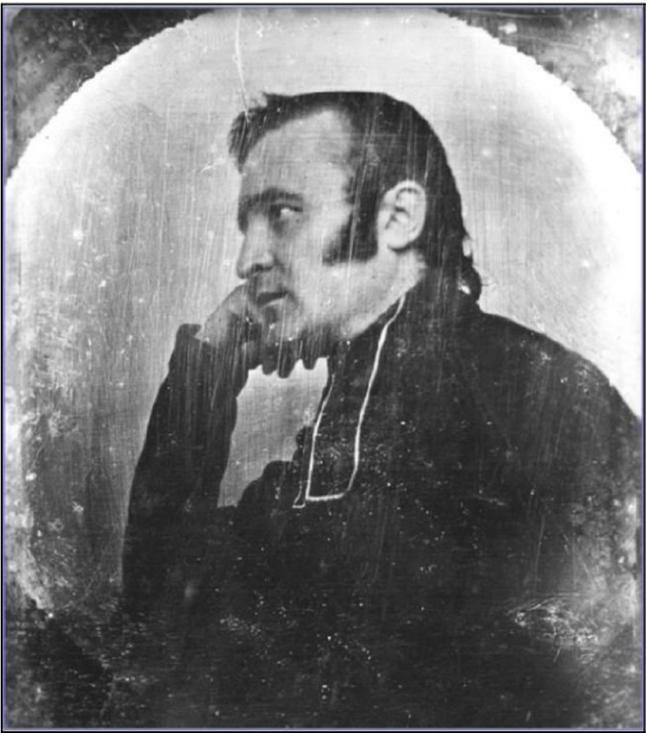
Daguerreotype of Father d’Alzon, around 1838-1840
“I felt growing within me the desire to defend religion at a time when it was being most attacked.”
(Lettres du P. d’Alzon, vol. A, p. 312, to his cousin Edmond d’Alzon, Lavagnac, 10 July 1832).

First Turning Point
“INTELLECTUAL CONVERSION” AND PRIESTLY VOCATION
September/October 1831
The event
- the decision of Emmanuel d’Alzon to be a priest and to go to the seminary
“It’s true, it was a very sad moment, the day I left Lavagnac... It was in fact extremely upsetting.” (Emmanuel d’Alzon, on the occasion of leaving Lavagnac for the seminary at Montpellier on 14 March 1832; from a letter to Luglien de Jouenne d’Esgrigny, 16 March 1832, Lettres, vol. A, p. 289)

Significant dates:

- 1828-29 (Paris) — legal studies in Paris, membership in various study groups (see below) and involvement in different charitable activities
- 1829-30 (Paris) — contact with the priest, Félicité de La Mennais (cf. letter of 12 January 1830); Emmanuel d’Alzon asks him (in 1829) for a study plan (Vailhé, vol. 1, p. 81ff, for further details)
- 1831 (October) — he tells his parents of his desire to be a priest
- 14 March 1832 — departure from Lavagnac for the seminary
- 20 November 1833 — departure for Rome

Description of the event
Emmanuel d’Alzon’s decision to be a priest was not easy. It came at the end of a long discernment, during which he considered other possibilities: a military career, law, political life... It should be said that he did not simply foresee a life of priestly ministry; he was not especially attracted by clerical status. His major preoccupation was for society and the Church, which he wanted to renew from the ground up. He finally reached the conclusion that to bring about such a renewal, the priesthood was the best means.
The preparation of a calling
To have a good understanding of Emmanuel d’Alzon’s decision to become a priest, we need to know something of his family experience and his adolescent years.
His family experience
The young Emmanuel was raised in a deeply Christian family very much attached to the Church. As a young boy, he was particularly fond of liturgical celebrations in Church and would even “celebrate” Mass with his friends, always taking on the role of the presiding celebrant. It is in his family that he learned that service, especially to the poor, was an essential dimension of the Christian vocation. As he will later explain, however, his early attraction to the priestly state faded during his adolescent years as a student in Paris.
His school experience
He did not stand out as a student at Saint-Louis and later at the Collège Stanislas, but as Vailhé explains (vol. 1, p. 48) his work improved considerably when studies drew more on his intelligence than on his imagination or memory. He read broadly while at Stanislas, sometimes in areas not always approved by his father (e.g. Montesquieu’s Esprit des lois and in general political philosophy). Nonetheless, his father would have liked to orient him in the direction of law and public service as a diplomat, in a government position or as a judge, but Emmanuel’s preference was to follow in the footsteps of his ancestors and, by means of a military career, be at the service of the king, restored to power now after the Revolution of 1789. When he asked his father in 1826 to enroll in the military academy of Saint-Cyr, the Viscount urged him to finish his literary studies (for which he maintained a lively interest and a desire to build up a substantial library) and not act impetuously on this attraction to the military life. By May of 1827, Emmanuel seems to have given up on the idea of Saint Cyr. He turns instead to the possibility of being a deputy in Parliament, in that way following more directly in the footsteps of his father.
His intellectual formation
By the time Emmanuel received his bachelor’s degree from Stanislas (August 1828), he had studied philosophy, history (with a particular interest in the Reformation, the Revolution, and religious wars), and classical literature. Study notes from the period reveal an inquisitive and critical mind. This intellectual vitality is evident from his participation in many study groups for young people organized in Paris at the time. He was a member at various times of the Société littéraire (founded by Emmanuel Bailly for Catholic students), the Société des Bonnes Etudes for Catholics and non-believers alike, the Association pour la défense de la religion catholique and the Conférence religieuse. Participation in these groups enabled the young student to keep up with current literary, philosophical and political issues and to be introduced to some of the important intellectual figures of the day. Among these, Félicité de La Mennais, whom d’Alzon met in April 1828 at the Conférence religieuse, would become one of the young man’s important teachers.
The last stage
On the advice of his father, however, he began legal studies in the Fall of 1828. He did so seriously, but did not hesitate to write to his friends that he found such study to be supremely uninteresting (“Legal studies are so boring!”, letter to Eugène de la Gournerie, 13 July 1829, Lettres, vol. A, p.24). At the same time, however, he continued to participate in informal study groups and took a particular interest in discussions of “public law”, i.e. the burning political questions of the day. He ordered his personal life seriously, attending daily Mass and engaging in charitable works (visits to the sick, religious instruction, etc.). When he began his second year of legal studies in Paris (in 1829), he took on La Mennais as his personal intellectual guide. The teacher responded by suggesting a plan of studies, but especially encouraging the young student to acquire “a system of ideas”, an overall intellectual perspective, which as La Mennais rightly said, can only be acquired by long, even daily exchanges between teacher and student. By January of 1830, the young man’s future orientation seemed to be clearly decided.
In a letter to his best friend (21 January 1830, Lettres, vol. A, p. 34), Luglien de Jouenne d’Esgrigny, by way of responding to his friend’s objections concerning his plan, the youthful d’Alzon laid out the steps in his discernment process and the reasons for his choice. He spoke of his initial attraction to military life, of the need to acquire some administrative experience, of his attraction to some form of legal service, or finally to a position as an elected member of the Chamber of Deputies. Early on he understood that he was called to “the defense of religion”, and at first he thought this could best be done in the context of a political career. This was the orientation for which Luglien would have argued (see his letter to d’Alzon of 23 January 1830, in Dossier sur la vie et les vertus, vol. 2, tome 1, p. 65: “You will be able to do a thousand times more good by avoiding the priest’s cassock... Your mission is to be an honest man among other honest men; your example in the world will be more useful than your example among priests.”) D’Alzon’s response was simple: “Early on I realized that sovereignty existed neither in the palace of the Bourbon nor in the Tuileries. And in a society as sick as ours, one can exert a real influence only by placing oneself at some distance from it...” Hence, the conclusion: “...gradually, my desires for a position in the world disappeared, and it was only the priesthood that I saw before me.”
It is important to emphasize the fact that Emmanuel d’Alzon understood the priesthood in the context of a very precise mission, “the defense of religion,” on which he reflected repeatedly in his correspondence from 1830 to 1835. What did he mean by “the defense of religion” and how did he hope to pursue this mission? Behind the expression lies an entire analysis of contemporary French society. For d’Alzon, his was “a sick society” (see above), in which the State has neither justice nor legitimate power on its side, where “God no longer rules.” He was aware of living “at a time when everything is in turmoil, everything is variable, uncertain, when the future is so unclear that everyone...is threatened”, a society fundamentally self-centered, in which “love is reduced to the most material level” (letter to Edmond d’Alzon, 10 July 1832, Lettres, vol. A, p. 312). The Church and its clergy are not spared in d’Alzon’s criticism: “Your depressing thoughts regarding the way certain priests live, these have plagued me for a long time. ...It’s hard to imagine why, humanly speaking, given the passionate excess for the past eighteen centuries of so many men dressed in cassocks of varying hues, religion has not perished, put to death by the teaching and the ethics of its ministers.” (ibid.)
Later, he summarized his analysis in a letter (18 March 1835, Lettres, vol. 14, p. 63) to Alphonse de Vigniamont: what is needed is “to restore to inquiring minds the strength that they have lost (and) heal the moral fatigue that people complain about on all sides.” D’Alzon found himself in a society that had lost its bearings. His desire, then, was to “renew” and to “regenerate” society, and he saw no better way than through religion, where he discovered “in the depths of Catholic teaching, such great wealth, a sap so strong, a life so powerful that...I cannot imagine how a priest who wants to renew society could find any other means than what he finds in the truth itself.” What is needed is “to enable this light to shine (on every mind), a light that guides everyone who comes into this world, that warms them with the rays of the eternal Word.”
To prepare himself for this mission, the young man dedicates himself to two years of private study at Lavagnac: the Fathers of the Church (Saint Augustine, Saint John Chrysostom, Tertullian, etc.), the Bible, Theology, languages (German, English, Italian). He focused especially on what he called “fundamental ideas”, i.e. those principles that can enlighten the mind of whoever is called, by vocation, to be a leader; because certain members of the clergy have set ideas such as these aside, they have absolutely no influence at all on society” (letter to Luglien d’Esgrigny, 11 August 1832, Lettres, vol. A, p. 323). Even after his arrival at the seminary of Montpellier, he continued along these same lines and complained about the poverty of the intellectual life in that milieu (see his letter to Henri Gouraud, 18 July 1832, Lettres, vol. A, p. 315, and to his sister, Augustine, 29 January 1833, Lettres, vol. A, p. 380).
Toward the end of this period of discernment, d’Alzon summarized the whole process in a letter to his sister Augustine. Certain things were clear to him:
- He was called to live among men (and not in a Trappist or Carthusian monastery).
- God wanted him to be a priest.
- He was not, however, called to ministry in the ordinary sense of the word.
- What more God was calling him to was not clear; what was needed was confident attentiveness. He considered it better not to force the future.
His decision to go to the seminary was thus the climax of a long process that was as much intellectual as spiritual and that led him to what we might call an “intellectual conversion”: “Each day there is a revolution going on inside of me, a revolution not from evil to good, though that is necessary, but in the sense that there are so many things that I am now seeing from a different point of view” (letter to Alphonse de Vigniamont, 18 March 1835, Lettres, vol. 14, p. 63). The fact is he was convinced of the importance of study and of Church teaching in any effort at renewal, whether it be in the Church or in society.
“From the beginning, his vocation is the fruit of reflection; it is, in that sense, ‘intellectual’. Emmanuel saw that the Church in his time was being attacked from all sides. He saw and was convinced that the Church was so poorly defended on the doctrinal level that his generosity pushed him at first to be one of its ‘lay soldiers’, then to understand that what was required was an even more radical commitment.” (Vailhé, vol. 1, p. 87)
From his early years to his leaving Lavagnac for the seminary at Montpellier, during the night of 14 March 1832, Emmanuel d’Alzon underwent a significant transformation and came to see his commitment to the service of the Church as intimately bound up with his commitment to the renewal of society. In the years to follow, his understanding of what this renewal entailed would also evolve', but already when d’Alzon was 22 years old, the general orientation of his priestly mission will be clear.
Conclusion
It is evident that d’Alzon’s vocational journey was not easy, but his desire to follow Christ and to respond to the deepest needs of society and of the Church of his day guided his entire discernment. He took every means at his disposal to discern the Lord’s call as best he could: spiritual direction, serious study and reflection, conversation with friends, and prayer. To reach his apostolic goals, he prepared seriously, especially in study. In a complex social and ecclesial setting, his discernment was characterized by tremendous freedom vis-à-vis his family and lucidity vis-à-vis the Church and the intellectual currents of the day. His example pushes us to reflect on our own attachment to Jesus Christ and on the apostolic passion that is ours.

Texts of Emmanuel d’Alzon that help us understand this turning point
- Letters of Emmanuel d’Alzon to Luglien de Jouenne d’Esgrigny (21 and 24 January 1830, Lettres, vol. A, p. 34 and 38)
- Thoughts on his study plan (February 1831, Ecrits spirituels, p. 745-749)
- Letter of Emmanuel d’Alzon to Edmond d’Alzon (10 July 1832, Lettres, vol. A, p. 312)
- Letter of Emmanuel d’Alzon to his sister Augustine (29 January 1833, Lettres, vol. A, p. 315)
- Letter of Emmanuel d’Alzon to Alphonse de Vigniamont (18 March 1835, Lettres, vol. 14, p. 63)

Biblical texts that help us understand this turning point
- Matthew 19:16-30 (the rich young man) and Mark 10:17-31
- Matthew 21:33-46 ; Mark 4, 1-34 ; Luke 4:16-44 (on the Kingdom)
- Matthew 13:44-46 (the treasure and the pearl, suggested by the 9 January 1831 letter to d’Esgrigny)
- John 4:4-42 (the Samaritan woman)
- Ephesians 4 (a solid doctrine)
- 2 Timothy 4 (a concern to teach, a sound doctrine)

Brief bibliography
- AUGUSTINE — Confessions, III, iv ; City of God, XIV and XIX
- Emmanuel D’ALZON —
Chapter of 1868 (on the Kingdom and the rights of God) (Ecrits spirituels, Rome, 1956, p. 129-146)
Letters to the Master of Novices (1-3), « The coming of the reign of our Lord, Jesus Christ » (Ecrits spirituels, p. 659-672)
- Siméon VAILHE, La vie du P. Emmanuel d’Alzon, Paris, 1926, vol. 1
- Emmanuel D’ALZON—Dossier sur la vie et les vertus, Rome, 1986

Excerpts

Letter of Emmanuel d’Alzon to Luglien de Jouenne d’Esgrigny (24 January 1830, Lettres, vol. A, p. 38): the stages of his discernment
If you’re unhappy to hear me talk about my future, if that diminishes your friendship for me, well, that’s it; I won’t talk to you about it anymore. Since one should love one’s friends for their sake and not for oneself, I’m resolved to never talk to you about anything until you can assure me that you love me enough to put up with my making you unhappy. Meanwhile, I’ll write.
You will simply not listen to reason. I scare you in a priest’s robe. Should I have expressed all my thoughts before I settled on an idea so repugnant to you?
Firstly, until the age of ten to twelve, the idea pleased me in a singular fashion. I abandoned it for a while and the career that attracted me the most was the military. I gave it up because of a few remarks from my parents. But, from about that time, I decided to consecrate myself to the defense of religion, and that thought has grown in me in a surprising way. From that moment, I felt an extreme repugnance for public service. I would have accepted to have a career, but it would have been for a short time only. It would have been in order to see how administration works.
So I saw only one battlefield worthy of me, the court of law, and I
believed I had to prepare myself for it by serious studies. Yet, by the
same principle that made me despise careers and because I believed that I was living in a lawless State, consequently lacking in legitimate power, I believed that where God did not command, I felt that I was made to aspire to sovereignty. And so, this sovereignty, in my opinion, was in the elected Chamber, and only in the elected Chamber...
I soon noticed that sovereignty existed neither in the palace of the Bourbon nor in the Tuileries. And in a society as sick as ours, one can exert real influence only by placing oneself at some distance from it and applying pressure on it with all the weight of the rights that it had no authority to give. From then on, my enthusiasm to become a deputy disappeared completely, and I saw in the French government only a decrepit machine that was useless, one that was even dangerous to try to repair.
With other considerations, I was led to conclude, as I formed a life-plan, that if I ever got established, I would do so by the age of 35 at the earliest, thinking with some satisfaction that, in the future, I would consecrate myself to God. Gradually, my desires for a position in the world disappeared, and it was only the priesthood that I saw before me. For this, I had nothing to sacrifice, since I no longer felt any attachment to the world. Do you know what frightened me the most then? It was my lack of enthusiasm; it was the cool detachment with which I considered the sacrifices I had to make and the possibility of profiting from it. The ease with which I believed I could make a break with my attachments frightened me; but what frightened me even more, was the total absence of enthusiasm. But that enthusiasm has finally appeared; there is nothing more to be afraid of except the weight of the burden that must be carried. The enthusiasm has come and continually grows, each time that I take communion. It has taken full possession of me, has removed a number of obstacles and made me desire the moment of my freedom, for we are truly free to the extent that we move to a more perfect order.
Now, my one desire is to do God’s will. I’m in no hurry though I’d like to enter into his service as soon as possible; but I’m calm and place myself entirely in his hands.
Everything that I’ve just said should prove to you that I’ve given all of this serious thought, that my only desire was to take the best means to carry out the task that I had assumed, that this development in my thinking is no regression and that, consequently, there is little reason to think that I am deluding myself.
Good-bye, dear Luglien. Respond and open your heart to me, as I’ve opened mine to you. At another time, I will explain how I see the priest. Maybe you won’t consider him so unlikely a friend and you won’t consider the cassock to be a bronze robe that keeps the heart from opening up and welcoming the outpouring of another.

Letter of Emmanuel d’Alzon to his cousin Edmond d’Alzon (10 July 1832, Lettres, vol. A, p. 312): he summarizes his thinking
It seems that my entering into the seminary has been the talk of many and in many different ways, but few have understood me better than you...
The good Lord has given me the grace to want to be devoted, and I have sensed growing within me the desire to defend religion when it is being most attacked. It pleased me to think at a time when everything was in turmoil, changing, and uncertain, when the future was so unclear that everyone, regardless of his state or opinion, was threatened, that I was attached to something fixed and unchanging and if I was exposed to some danger, that at least it was for a cause that was worth the cost. No doubt, I’ve said it to you before: nothing troubles me more than egoism, which I think is invading society nowadays.

Letter of Emmanuel d’Alzon to Alphonse de Vigniamont (18 March 1835, Lettres, vol. 14, p. 63)
Each day there is a revolution is going on inside me, a revolution not from evil to good, though that is necessary, but in the sense that there are so many things that I’m now seeing from a different point of view. As I study religion, I discover, in the depths of Catholic dogma, such a great wealth, such a rich vein, a life so powerful that, on the one hand, I do not see how a priest who wants to renew society can find a better way than the truth itself and, on the other hand, I think the only way to strengthen flagging spirits or heal the moral fatigue that everyone laments today, is to expose society to the brilliant light that guides all people coming into this world, to warm them all with the rays of the eternal Word.
...the more I look at the world from this point of view, the more I am disgusted with politics, which I consider to be a dead end. There is no life there, only death convulsions, powerless attempts to organize, vain efforts, unless Catholic thought penetrates it with charity, justice and the spirit of Christian liberty, which regardless of what they say is completed suffocated in our day.
...The most intimate thought of my soul is that the world needs to be penetrated through and through by a Christian idea; otherwise it will fall apart. And the world will not receive this idea but from men who will be taken up with it before all else in order to proclaim it in every form that it might assume. They say the world is evil. No doubt, passion turns it away from what is good. But I believe most of all that the world is ignorant. Therefore we need to teach it and to do so in words it can understand.
Richard E. Lamoureux, a.a.

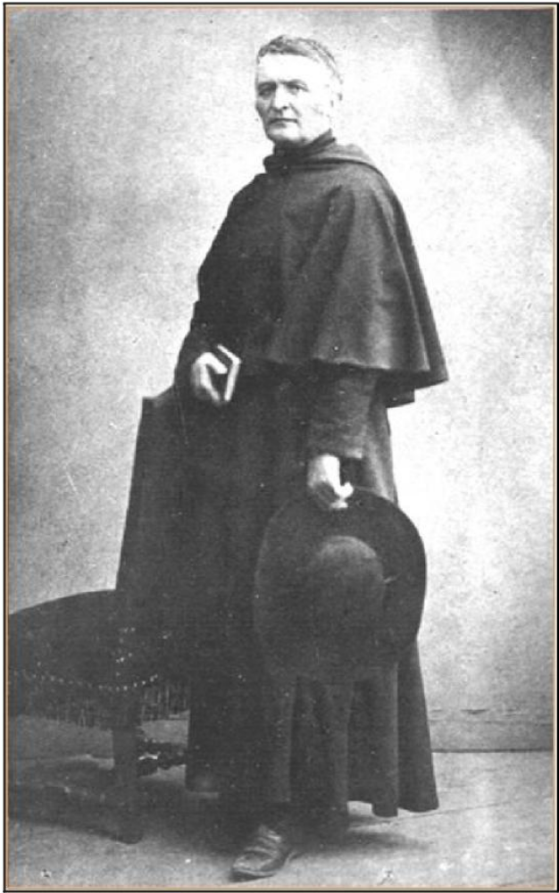
A photograph of Fr. d’Alzon, standing, with hat in hand, 1859- 1862
21
This Roman hat is not an insignificant detail : Fr. d’Alzon wanted to show himself as ultramontane, “always faithful to Rome.”

Second Turning Point
FATHER D’ALZON AND HIS LOVE FOR THE CHURCH
An act of obedience
12 December 1834
A formal adherence to the teaching of the Church
is requested of him directly by the Pope

One of the fundamental aspects of Emmanuel d’Alzon’s spiritual experience and his journey of holiness was his love for the Church. He communicated this love to his followers (Assumptionists, Oblates of the Assumption, his spiritual directees, the lay people with whom he collaborated, the students at the College) as one of the essential elements of the charism and the spirituality of the Assumption.
At 24 years old he displayed a love for the Church that was both mature and solid, and this only deepened over the years. This love is based on a rich theology of the Church and, at the same time, on the practice of certain virtues that he lived in a heroic manner.
Also, it should be noted that Emmanuel d’Alzon’s love for the Church was lived harmoniously at two different levels: fidelity to the universal Church (manifested in his veneration for the Pope and his unconditional obedience to him) and his fidelity to the local Church (which he served with generosity, daring, creativity and disinterestedness during his entire life).

The event
- 12 December 1834, an act of submission
On Friday, 12 December 1834, on the eve of his ordination to Major Orders, at the request of the Pope (Gregory XVI) and in the presence of the Cardinal Vicar of Rome (Carlo Odescalchi), he was asked to sign a formal act of submission to the encyclicals Mirari vos (1832) and Singulari nos (1834). In so doing he was explicitly stating that he did not share nor defend the ideas of Félicité de La Mennais.
The request was unexpected. Why was this act of submission being asked of Emmanuel d’Alzon as a kind of condition for his being ordained a priest? Did the Pope himself doubt the integrity of his Catholic faith and his obedience to the teachings of the Church? It was a sad moment for the young d’Alzon, at a time when he had decided to give his whole life to the service of the Church. In a letter addressed to his father on the day of his priestly ordination, he gives his own account of the event, attempting to find an explanation and communicating his feelings with the passion and the sincerity that is typical of him. D’Alzon’s determination and vivacity have often been underlined: he did not delay for a moment and signed immediately.
It would take me too long to tell you how troubled I was before my ordination... They played a nasty trick on me. I believe it was the Bishop of Puy. Whatever the case, they denounced me for my opinions. No one tells me anything... And then, in the name of the Pope, they obliged me to sign a document, affirming my adherence to the encyclical... They offered to give me time to think. But I responded that I needed no time and I signed on the spot... It is very troubling to attract the Pope’s pleasure in this way... (Letter to his father, 26 December 1834, Lettres, vol. A, p. 759-762)

A reflection: for a better understanding of the event of 12 December 1834
1. First of all, it should be said that during his entire stay in Rome Emmanuel d’Alzon was living in the midst of what might be called the “La Mennais crisis”, from early November 1833 until June 1835. He was “a special disciple at the heart of the drama” (BORDET, p. 56). He was not simply a distant spectator. On the contrary, he was in continuous communication with a certain number of well-informed Roman Church figures and understood, better than many other friends and disciples of La Mennais, the various debates and differences that existed within the Roman Curia itself. He was an attentive and lucid observer and was able to maintain a healthy balance given on the one hand his clear sympathies, his admiration and even his friendship for La Mennais and on the other his intellectual convictions and his fidelity to the decisions of ecclesiastical authorities. Emmanuel and his Roman friends tried to encourage and support La Mennais, but they also did everything they could so that he would remain faithful to the Church.
De la Mennais is condemned by an encyclical... Since I am totally submitted, I am at peace as far as I am concerned, but I am very concerned about the consequences, and I am not alone... Good-bye for now. I am nonetheless a bit annoyed, but I won‟t do anything stupid. Again yesterday I went to kiss the feet of Saint Peter and to ask him for courage, for myself and for those who are in need. (Letter to his sister Marie, 30 June 1834, Lettres, vol. A, p. 597-598).

Finally Rome has spoken. In a new encyclical, the Pope has condemned your work without mentioning you by name. No extracts are specifically cited, but the entire book in general is censored. Your friends are deeply pained. They are submitted, but are concerned for the bad repercussions that they foresee. They have asked me to urge you to remain completely silent and to let time take its course. In a few days I will communicate to you the information that I have gathered together. I barely dare to speak of my deep affliction and the ardent desire that I have that this new trial, however painful it might be, in no way jeopardize your attachment to the Church of Jesus Christ. (Letter to La Mennais, 1 July 1834, Lettres, vol. 14, p.46)

2. But Emmanuel suffered because of the petty atmosphere and the political-religious intrigues that he discovered in the Roman milieu and in the Church’s administration. He rebelled against this state of affairs. His correspondence reveals his criticism, at once both severe and bitter. He understood that he was himself being criticized and judged by some. But despite the all too human and hardly evangelical ambiance, he strongly reaffirms his faith and his confidence in the divine strength of the Church and in its supernatural dimension.
I don’t know if I will be able to get used to Rome. To get used to something, you need to understand it, and for me Rome is a mystery that I’ve just recently discovered, a mixture of faith and abuse, of virtue and decadence, of strength and weakness, of the politics of fear and love of the good, all of that combined, mixed together. Figure it out if you can! The most active minds wear themselves out on questions that are of little importance and neglect the most vital of issues... Good-bye for now. Yes, I need you because I’m passing through a painful period. Seeing certain evils in the Church has a painful effect on me, no doubt because my faith is weak. However, one needs to be prepared for combat. (Letter to d’Esgrigny, 24 February 1834, Lettres, vol. A, p. 507-511.)

If you want to know the effects of these events on me personally, it has been to make me suffer greatly, but also to purify my faith, to cause it to rest more and more on God, to make me want only the good of the Church. Oh, how everything is so small and weak and full of illusion. Pray God, I beg of you, so that I learn from all of this lessons of humility and hope... (Letter to Fr. Fabre, 24 August 1834, Lettres, vol. A, p. 664-665).

I cannot hide from you the fact that all of these trials have caused me great suffering. Fénelon, after his condemnation, said: “I submit myself, but I do so in tears.” As it is, my submission was very easy because I recognized that M. de la M[ennais] was in error, it is the blow itself that was cruel, and I could say that I have submitted myself, but roaring like a lion... I think that, of all the suffering, the greatest that can fill the heart of one who loves the Church is to see her interests compromised by those who should be defending her. (Letter to his father, 25 August 1834, Lettres, vol. A, p. 667)

I tried to submit myself with the simplicity of a child; then I tried to understand the words of the encyclical in a way that seemed the most natural to me. I clearly understood that they were critical of something, but that the something was not of major consequence. (Lettter to his sister Augustine, 17 January 1835, Lettres, vol.A, p.771)

As for me, I study each day and am strengthened by a few sayings whose importance my trip helps me to understand. The first of these is that one must always work with Rome, sometimes without Rome, but never against Rome. (Letter to Fr. Fabre, 23 August 1836, Lettres, vol. A, p. 658)

3. Much has been said about the interior struggle that all of this must have meant for Emmanuel d’Alzon: to have to choose between his friendship and loyalty vis-à-vis La Mennais and his fidelity to the Church. We could imagine a deep separation and break-up. It is true that d’Alzon admired La Mennais‟ brilliant personality, and that d’Alzon was enthusiastic about his ideas and projects. He had even asked him to be in some ways his intellectual mentor. Nonetheless, it is also true that Emmanuel had already made his choice at 20 years old, a very clear choice to which he remains faithful all of his life: to work for the “defense of religion” and for the rights of God in society, to free the Church from all political powers, to fight for the “regeneration” of society. This mission was for him both “beautiful and sublime” (Lettres, vol. A, p. 332). D’Alzon’s perspective was generally optimistic, suffused with Christian hope (Lettres, vol. A, p. 345). His choice is a choice in faith, an option for the Church. However, for La Mennais, the choice was rather for a struggle at the level of politics.

I don’t know everything that awaits me once I’m ordained a priest. I know that today I am sacrificing my freedom, which is quite necessary. I have thought a great deal as to whether I might be able to do good more easily by staying in the world as a simple Catholic. But it seems to me that God wants me elsewhere and that it is as a priest that I must work. (Letter to La Mennais, 26 November 1834, Lettres, vol. 14, p. 53)

I can assure you that, while I still agree with many of the ideas of M. de la M[ennais], I diverge from him clearly regarding politics... He is convinced that today we cannot and should no longer talk of religion, that everything must be dealt with at the level of politics. I believe, on the contrary, and I am convinced that everything must be dealt with at the level of religion... I am speaking now as a priest and not simply as a Frenchman. There is in this mistrust of the strength of the Church something that is harmful to the truth and to the nature itself of Catholicism which thus appears to be unable to defend itself with its own strength. (Letter to his father, 28 March 1834, Lettres, vol. A, p. 797-798)

Conclusion
D’Alzon’s act of submission on 12 December 1834 is an important mile-stone on his path of holiness. It was before all else an act of faith in the Church and of supernatural love for her. “If d’Alzon loves the Church so much, it is not that he is unaware of her shortcomings. But beyond these, he believes in God’s action and promise. His correspondence during his stay in Rome makes it clear that his attachment to the Church and to the Holy Sea is for him a matter of faith.” (Dossier sur la vie et les vertus, vol. I, p. 67).

Biblical texts that help us understand this turning point
- 1 Corinthians 12 (diversity and unity in one body)
- Ephesians 4 (Church, Body of Christ)
- John 15 (the vine and the branches)
- Revelation 12 (the Woman and the Dragon)

Brief bibliography
- Siméon VAILHÉ, Vie du P. Emmanuel d’Alzon, Paris, 1926, vol. I (1810-1851), chapter VII, VIII, IX, p. 134-204.
- Gaston BORDET, « Emmanuel d’Alzon et la crise mennaisienne 1828-1835 », in Emmanuel d’Alzon dans la société et l’Eglise du XIXe siècle, Colloquium under the direction of René RÉMOND and Emile POULAT (December 1980), Paris, Editions du Centurion, 1982, p. 37-82.
- Jean-René DERRÉ, « Les relations entre E. d’Alzon et Lamennais, en Emmanuel d’Alzon dans la société et l‟Eglise du XIXe siècle », in Emmanuel d’Alzon dans la société et l’Eglise du XIXe siècle, Colloquium under the direction of René RÉMOND and Emile POULAT (December, 1980), Paris, Editions du Centurion, 1982, p. 83-106.
- Dossier sur la vie et les vertus du P. Emmanuel d’Alzon, Rome, 1986, vol. I : Sommaire de la vie et des vertus, p. 63-68 ; vol. II : Documentation Biographique, tome I, chapter VI and VII, p. 125- 247.
- Jean-Paul PÉRIER-MUZET, Le Pere Emmanuel d’Alzon par luimême. Anthologie Alzonienne, Rome, 2003, vol. I, chapters 6 and 7 ; vol. II, chapters 5, 6 and 7.
- Polyeucte GUISSARD, Le Père Emmanuel d’Alzon, fondateur des Augustins de l’Assomption — 1810-1880, Paris, 1935.
Julio Navarro Román, a.a.

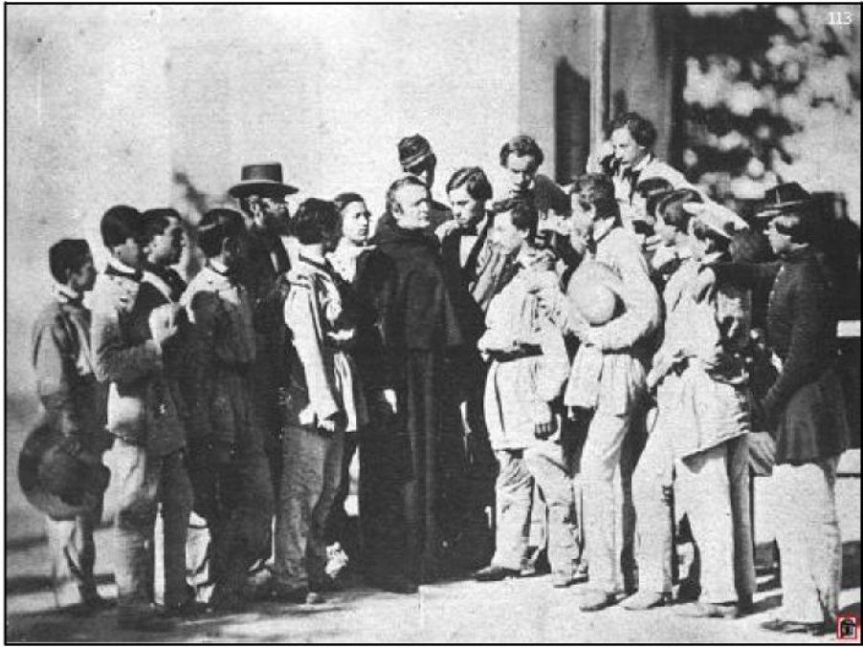
Fr. d’Alzon, with Mr. Germer-Durand, surrounded by students, Photographed by Disderi, around 1852-1853

Third Turning Point
THE CHOICE OF A SCHOOL AND A RELIGIOUS VOCATION
“Years of fire”
The event
- The “choice” to accept the direction of a College and the “birth” of a religious vocation

Significant dates:
- 22 January 1844 : along with Fr. Goubier, Fr. d’Alzon (34 years old) assumes responsibility for the Assumption boarding-school in the center of Nîmes, as “owner” (formal purchase in 1843) and as administrator
- June 1844, at the shrine of the Consolata in Turin: Emmanuel d’Alzon vows to refuse all ecclesiastical honors
- June or July 1844, at Notre-Dame des Victoires in Paris: Fr. d’Alzon professes private religious vows and, upon his return to Nîmes, takes up residence at the College and lives as a religious as of September 1845
- 16 August 1844: Emmanuel d’Alzon reviews his discernment process as a religious in a letter to Mère Marie-Eug6nie de J6sus, with whom he works at the drafting of Constitutions for the Religious Sisters of the Assumption

Description of the turning point
In Siméon Vailhé’s Chronologie de la vie du P. Emmanuel d’Alzon, this period (1844-1851) is called “The Origins of the Assumption”. In that sense it is a time of beginnings, an important period of foundation. It could be called “The Years of fire.”
While continuing his work as Vicar General, Emmanuel d’Alzon was undergoing an apostolic conversion by assuming responsibility, almost despite himself, for the Assumption boarding-school as of the beginning of the 1844 school year, and this right after the foundation of the Carmelite convent in 1843 (an indication of the importance that Emmanuel d’Alzon attached to prayer). With the advice of two lay University graduates, Eugène Germer-Durand and Jules Monnier, d’Alzon elaborated a number of educational principles, on the basis of the pedagogical practices and the experience of Mère Marie-Eugénie de Jésus (Sage, p. 31): a great deal of freedom at the heart of the institution, the active participation of the students, preparation for active involvement in society, the formation of minds and hearts by faith in Jesus Christ and love of God, and all with the help of Christian parents.
Along with this work, Emmanuel d’Alzon lived privately and then publically a conversion to religious life. Already in 1833, he had a desire to be a priest-religious, but an apostolic religious (see the two letters of the cleric Daubrée to d’Alzon in June and July of 1833; see Dossier sur la vie et les vertus, vol. II, tome I, p. 100-101). Almost ten years later, the “star reappears” (Letter to Marie-Eugénie, 20 December 1844, Lettres, vol. B, p. 210), and Emmanuel thinks of founding himself a new kind of religious apostolic community, thanks to the strong urging of Marie-Eugénie, whose spiritual director he was (see the exchange of letters in August of 1844). The team of professors chosen by d’Alzon ran the College, where a community made up of priests and lay people was born. D’Alzon would call this community the “Petite Association de l’Assomption”.
By the vow he had taken at Turin in June 1844, Emmanuel d’Alzon had already decided to “forego all ecclesiastical honors” and even “to refuse all responsibilities” tied to a Church career (Ecrits spirituels, p. 639).
In this way, he would be able to “devote himself to the formation of a religious community” despite his awareness of “serious deficiencies” and the “qualities” that would be needed (Ecrits spirituels, p. 641) What kind of community? He is not quite sure and wants to remain obedient to God’s will (see letter to Mère Marie-Eugénie of 24 June 1844, Lettres, vol. B, p. 160).
These two conversions of Emmanuel d’Alzon, an apostolic conversion and a conversion to religious community life, will grow and strengthen until 1851, during the five formative years of novitiate (Christmas 1845 to Christmas 1850). The period ends with the profession of public vows (with a fourth, for the extension of the Kingdom of God). With the agreement finally of his Bishop, Msgr. Cart, he professed these vows in the chapel of the College, in the company of his first four disciples: Henri Brun, Victor Cardenne, Etienne Pernet, and Hippolyte Saugrain.
Note that La Mennais’ influence on d’Alzon’s thought regarding the faith was important, but the Augustinian influence on his theology, on his thinking regarding religious life in apostolic community, and on his spirituality will remain preponderant.
We can imagine that like Augustine a series of conversions will orient Emmanuel d’Alzon’s entire life and have a significant impact on his path of holiness. These “years of fire”, from 1844 to 1851, are an example of that.

Texts of Emmanuel d’Alzon that help us understand this turning point
- Letter of 16 August 1844 to Mère Marie-Eugénie on the orientation of his religious vocation (Lettres, vol. B, p. 183)
- Letter of 24 December 1850 to Mère Marie-Eugénie, just before his first public profession of religious vows (Lettres, vol. C, p. 639)

Biblical texts that help us understand this turning point
- Mark 3:13-19 (the call of the Twelve, like the « Petite Association de l’Assomption »)
- Matthew 13:44 (the parable of the hidden treasurer)
- Matthew 13:33 (the parable of the yeast hidden in the dough)
- Matthew 2:2 (the symbol of the star followed by the Magi at Christmas)

Brief bibliography
- Athanase SAGE, Un Maître Spirituel au XIXè siècle, Rome, 1958, p. 25ff.
- Emmanuel D’ALZON, Ecrits Spirituels, « Les débuts de l’Assomption », p. 769 to 807.
- Emmanuel D’ALZON, Premières constitutions des Augustins de l’Assomption 1855-1865, Rome, 1966.
- Dossier sur la vie et les vertus d’Emmanuel d’Alzon, Rome, 1986.
- Richard E. LAMOUREUX, “D’Alzon on Education and the Transformation of Society”, unpublished essay, 1997, p. 6.
- Jean-Paul PÉRIER-MUZET, Le Pere d’Alzon par lui-même, vol. II, No. 13 « Désir de fondation d’une congrégation », « Dans l’aventure d’un collège », and « Une révolution à Paris ».
- Jean-Paul PÉRIER-MUZET, Prier 15 jours avec E. d’Alzon, Paris, 2003, p. 21ff.
- Siméon VAILHÉ, Vie du P. Emmanuel d’Alzon, vol. 1, Paris, 1926.

Excerpts
E. d’Alzon presents his “vocation” in response to a question from Mère Marie-Eugénie (16 August 1844, Lettres, vol. B, p. 183):
I would like to be a bit self-centered today, dear child, and begin to respond to your last letter, the one in which you speak about my future projects. I cannot hide from you the fact that the thought of being a religious has long been on my mind, though I have never felt myself called to an existing Order. And if at the present time I knew very clearly that God wanted me in a particular place, as I knew he wanted me to be a priest, I would not hesitate for an instant. But I can assure you that I do not discern any precise direction in me at this time, at least in the current state of my soul. Consequently, I need to wait until God acts, praying that he makes me do what is pleasing to him and forcing myself to be open to his views if he has some for me at this time.
This is how I see things. I think that if I have some capacity to do what you would like, I am also lacking in many qualities: I am not persevering enough; I let myself be too carried away by the thought of some good to be accomplished without measuring, as I should, the kind of good that I should pursue; I am not organized enough. This is especially a consequence of my temperament, but it is no less true that I present many natural obstacles to supernatural action. For a while now, I believe that I am becoming more organized and persevering, but not sufficiently to be able to impress these things upon others.
One also has to consider certain material facts. Among the works for which I am currently responsible, there are three that I cannot abandon without further consolidation: the Refuge, the Carmelites, and the College or boarding school that I have established. The Refuge will be able to stay on its own in a short while. As for the Carmelites, I believe they are still in need of support for at least another two or three years. The boarding schools weighs on me quite a bit more. To withdraw at this time would be disastrous, because of the position of the clergy vis-à-vis the University, and I foresee that I will have to commit considerable sums of money to the project. At times I have thought of going there to live, precisely in order to observe people and the characters that God will send to me or, simply, will send, for if I found someone to whom I could entrust things, I would do so willingly.
...Whereas I do not like the Jesuits any more than you, I do not judge them exactly as you do. There are four things that cause me not to be attracted to them: 1) their exclusive character; “nothing is beautiful, good or perfect other than the Society, non est ex praedestinatis qui non est amicus Societatis”; I consider that terrible; 2) their secretiveness; it is said they are changing on this score; 3) their lack of spontaneity or “naturalness”, probably a consequence of the methods used to “break” them; 4) their incapacity to understand, at least up until now, what I call Catholic freedom and which, I believe, will allow the Church to be triumphant in the current struggle.
The moral basis that I would give to a new Congregation would be: 1) the acceptance of everything that is Catholic; 2) frankness; 3) freedom. You’ll understand that I have nothing to say about what is necessary for an Order to be an Order; I am only indicating what I think should distinguish a modern Congregation from those currently existing. I repeat: I know nothing that can cause self-love to die more effectively than the acceptance of everything that is outside of oneself; I know nothing that wins over men today more than frankness; and I know no better way to fight against the enemies of the Church today than freedom itself.
These thoughts could be better or more fully developed, but they are I think easy enough to grasp. As for a “dogmatic thought”, if I can use that expression, it can be summarized in a few words: to help Jesus continue his mystical incarnation in the Church and in each member of the Church. For I believe that in following this idea we can present Catholic truth to its best advantage against the pantheist and material errors of the day.
...In a few words, if God wants me to attempt something, I think he is asking me to wait for another while. In any case, I will make every effort to set aside every obstacle that personally I might put in the way of his project. In that regard, I accept your prayers and the day of the week that you will give me.
...I fully agree with your way of presenting things in terms of what you call the passion and the philosophy of religious Orders. My passion would be the manifestation of the Man-God and the divinization of humanity by Jesus Christ. That would also be my philosophy...

Emmanuel d’Alzon Profession formula, 1850 (Ecrits spirituels, p. 807); see also « Formule de l‟engagement des Laïcs du Tiers-Ordre avec le quatrième vœu » (Premières Constitutions, p. 190):
Ego Emmanuel Maria Joseph Mauritius Daudé d’Alzon, professionem facio et promitto omnipotenti Deo coram ejus virgine matre in caelos assumpta, et universa caelesti curia ac omnibus circumstantibus, paupertatem, castitatem et obedientiam, et secundum eam peculiarem curam circa juventis eruditionem.
Insuper specialiter promitto me aucturum pro viribus regnum Domini nostri Jesu Christi apud animas tam christianorum quam infedelium. Nemausi in nocte natali Domini nostri Jesu Christ, Anno millesimo octingentesimo quinquagesimo. E. d’Alzon.

N.B. In this text, the education of young people (school, different groups...) constitutes a fourth vow, and the extension of the Reign of Jesus Christ (with a missionary connotation) is presented as a fifth vow.

The spirit of education (Ecrits spirituels, p. 1329ff.), « Principes d’éducation chrétienne ». See also A. Sage, Un Maître Spirituel, p. 31-32.
We need to be strongly shaped by the Christian thought, faith, and love that come from our knowledge of God and of His Church, and communicate this thinking everywhere and as forcefully as possible in the minds and hearts of our students, so as to influence their entire being, without becoming discouraged by the obstacles that their ignorance and lack of seriousness might present.
How are we to communicate this strength, this faith, this love among our students? ... If a Christian, in communion with God, is open to divine grace, he will find that he is made fruitful by the being of God. In the Father, he will grow in understanding through the Son, and the more he knows the truth, he will be drawn toward it, be attached to it, love it; it is the Holy Spirit who will then draw close, take hold of the Christian and lift him to Himself. ... This is a Trinitarian approach to education.
Power. In what way is it necessary? ...by introducing us to the power of God Himself, ...by learning about all of the help that is given to us to lift ourselves up, to restore our dignity... With our students, let us imitate God in His creative activity...; let us be good models for them...
Intelligence. One of the ways to communicate this power is by teaching, which makes the truth itself known.
Love. Truth is not simply a part of a system, something for the Christian to reflect on. It is most of all an object of love; and the one who seeks it, who desires it, once he possesses it will be impassioned for the truth... (an Augustinian approach to education). This is a love that we find in God and in the Church.

See also Siméon Vailhé, vol. 1, chapters 17 and 22

Lucas Chuffart, a.a

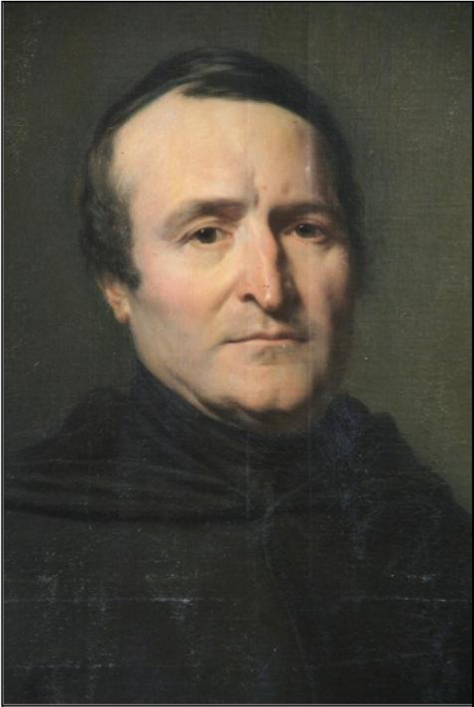
Fr. d’ALZON at rest at Lavagnac in 1856
Fr. d’Alzon’s features clearly reveal the effects of his ill-health. According to those close to him, he did not find this portrait especially flattering: “I would have preferred the bigger portrait, but others do not like it.” Text quoted from a letter of 15 April 1869 to Mère Correnson (Lettres, vol. VII, page 194).

This portrait hung in the entry hall of the Chateau at Lavagnac, while Fr. D’Alzon’s parents were still living.

Fourth Turning Point
TRIALS AND SPIRITUAL CONVERSION
1852-1858
The event
- 19-20 May 1854: cerebral hemorrhage followed by paralysis and the suspension of all activity
- 29-30 October 1856: “The establishment in Nîmes (the College) will cease to exist.”

Description of the turning point
A kenosis moment
1854. Emmanuel d’Alzon had been a religious for almost five years. During the entire period his life was given over to the Church, to teaching, to his new religious family, the Assumption. In addition to these projects, he founded a number of others in various domains. His reputation was spreading broadly, to the point where in August of 1850 he was named a member of the “Conseil Supérieur de l’Instruction publique” in France and was asked on two different occasions (in 1848 and in 1854) to become a Bishop. This fame, however, had its shadow side.
Physically, all of this hard work provoked fatigue, chronic headaches, and in general burn-out. In addition to these physical ailments, d’Alzon was plagued with debts threatening the existence of a number of his projects. There was so much debt that he was beginning to fear the end of his Congregation. It should also be said that the number of religious persevering in their commitment was hardly impressive. For example, on 25 December 1851, the date of the first perpetual profession in the history of the Congregation, there were fewer than ten religious, only four of whom were perpetually professed: fathers Emmanuel d’Alzon and Henri Brun and brothers Saugrain and Pernet. At this pace, the future of the community was hardly assured.
By 19 May 1854, overwork, sleep deprivation, worries, excessive zeal all provoked a cerebral hemorrhage with resulting paralysis, which by the following day became critical. This was the beginning of a long way of the cross, at once physical, moral, intellectual and even spiritual. It lasted three years. This cross obliged him, despite himself, to withdraw and rest on a number of different occasions and in the end to resign from the direction of the College in October of 1855. As if this were not enough, while dealing with these physical ailments, another crisis erupted. Without funds and deeply in debt, some of his works were closed down and even sold to meet debt payments. This was the decision of his family, which was no longer in a position to support his work. In the face of such suffering and failure, by 1857 he was, like his Master, in the garden of Gethsemane. Many of his friends, otherwise well-intentioned, suggested that he take some distance from his confreres and sacrifice his small Congregation.

Also a time of conversion and “ascension”
A man of his day, during this period of suffering d’Alzon had recourse to the medical practices of the times, principally thermal bath cures. The spa at Lamalou was particularly important; it could be considered Mount Sion for the Assumptionists, because, as Father Jean-Paul Périer Muzet wrote: This was where “d’Alzonian spirituality reaches its summit.” For it was here that he wrote at least two major texts: the Directory and the “The Friend of Each and Every Day.”
But d’Alzon would be reborn most especially by means of his unshakable faith in God. Even more than earlier in his life, he showed himself to be a man of intense and constant prayer, a man who surrenders his life and his future into God’s hands. Consequently, we can speak of a long way of the cross, but at the end of this path he discovered new life both for himself and for his Congregation, a life laid down before God and rooted in Him. Adrien Pépin will write of this path as Emmanuel d’Alzon’s spiritual ascension. In fact, it is in such a context that d’Alzon will repeat the words of Saint Paul: “For me to live is Christ (and death is a gain).” He invites his disciples to do likewise and to see in the cross “an intimate friend of each and every day.” (See his letter of 21 June 1857, written from Lamalou to the Adoratrices du Saint Sacrement, who had been recently founded on Pentecost of 1857; Lettres, vol. 2, p. 266)
A spiritual ascension for d’Alzon, but also a renaissance for the College and for the Congregation. If during the period before this long way of the cross d’Alzon was the passionate apostle taken up with a thousand things to the point of not having enough time for his Congregation, because of his sickness he will now spend more time caring for the life of his religious family: “What Our Lord seems to be asking of me especially is to withdraw from many things in order to tend to the foundation; to leave aside everything that does not have to do with that. And it is during this period of collapse and spiritual ascension that the spirituality of the Congregation will take on considerable substance and the first Constitutions and the Directory will be drafted.
Who has not experienced such moments of weakness and collapse? This is a model of holiness that enlightens the way when we find that our projects face an uncertain future and tomorrow seems bleak. This is a path of total surrender to God, who does not abandon the one who puts his faith in him (Sirach 2:1-11).

Biblical texts that help us understand this turning point
- The struggle of Jacob in Genesis 32:23-33 [Note the extent to which prayer is a struggle that requires an asceticism that leaves us “weakened”, wounded, if perhaps also blessed.]
- Sirach 2:1-11
- John 15:1-17 (the image of the vine)
- John 18:28-19, 30 (quoted in the letter to Mère Marie Eugénie, 30 October 1856, in which d’Alzon says he accepts the closing of the College in faith)
- 1 Corinthians 2
- Galatians 6:11-14 (quoted in the letter to Mère Marie Eugénie, 14 September 1854)

Texts of Emmanuel d’Alzon that help us understand this turning point

Texts on spiritual conversion
Letter to Mère Marie Eugénie (14 September 1854 ; Lettres, vol. 1, p. 459)
[...] I spare you the details regarding the rest of my trip. Once in Nîmes, I found that I could count on only 125 students. Fr. Hippolyte had prepared the budget for me, indicating that we needed to eliminate 23,000 francs in salaries for teachers. With that, we would still have a deficit of 20,000 francs. I am quick to report all of this, but I am not worried. God gave me the grace today to understand the difference between those who can say: “Mihi absit gloriari nisi in cruce Domini Nostri Jesus Christi.” (Galatians 6:14), and those who cannot, and especially the journey one must make in order to say this perfectly. I do not believe that I have arrived at the highest point in terms of this attitude, but I believe I want very sincerely to do so. The night of faith seems like an abyss, into which one must enter holding onto the cross, accepting everything that the cross teaches and signifies. That’s the state I’m in, and since at the deepest level it helps me to find peace and more love for Our Lord, I give myself to it as much as I am able...”

Letter to Mère Marie Eugénie (15 January 1856, Lettres, vol. 2, p. 8)
[...] Good-bye for now, my daughter. Allow me to say that my sickness is doing me a great deal of good, and while I pray that God may deliver me from it, I thank him for helping me to understand in this way that one must rely only on his strength in all things human and supernatural.

Letter to Mère Marie Eugénie (12 June 1856, Lettres, vol. 2, p. 99)
[...] All in all, the stay at Lamalou will have been most useful to me. I am not only talking in terms of health, which seems to be doing better, but especially in terms of my soul which is more at rest, more calm and which, during these long hours of solitude, senses the need to remain always a bit more to the hand of God. I’ve been reading the Imitation of Christ and the New Testament, and only that. The Imitation has always done me a great deal of good. I’m rediscovering in the New Testament a flavor that for a while had been lost, and for that I am happy. I love Jesus Christ and the Church always a bit more. I was reading this verse in Saint Paul: “Vosmetipsos tentate si estis in fide: ipsi vos probate. An non cognoscitis vosmetipsos, quia Christus Jesus in vobis est ? nisi forte reprobi estis” (2 Corinthians 13:5). This criticism of having lost a sense of the presence of Jesus Christ in us is terrible. And yet what a transformation if we sense him constantly in us! I’ve taken the resolution to try to sense as much as possible this divine action and to remind you of it as well, dear child, since that is our great good, Jesus Christ! Oh, if we could be filled with this life of faith! If only we truly desired this fusion of the life of Jesus Christ with our own, and the fusion of our own with Jesus Christ! But can we even think this without being deeply humbled by the poverty of our interior life, animated as it is by miserable motives? I ask God to fill me with an awareness of the greatness of every action accomplished by Jesus Christ living within me, who is to my soul what my soul is to my body.
Adieu, my daughter. Pray for me and trust that the thoughts that I have just communicated to you in part draw me closer to you in the love of Jesus Christ.

Texts on the closing of the College at Nîmes
Letter to Mère Marie Eugénie (29 October 1856, Lettres, vol. 2, p. (Very confidential)
Well, my dear daughter, the sacrifice is accomplished; the college of Nîmes will not survive. M. Berthomieu, who came here, is of this same opinion. We will not meet our budget this year. We have to see in this impossible situation the hand of God and bless it. I can’t say how much your good friendship means to me in these moments that are somewhat painful. Nonetheless, do not be mistaken; I am not suffering except that all night long I had a headache and troubles with my teeth, and I’m assailed by my old temptation to unbelief. In the end, I do my best to let God do what he wills, and it seems that I have never been less well prepared to appear before him. I got up a bit later because of my ailments, and I’ll leave you to go celebrate Mass.

Letter to Mère Marie Eugénie (30 October 1856, Lettres, vol. 2, p.
The letter from you that I just received thanks to Mme Durand, I believe, has brought me great pleasure. What a word! My decision is taken, and it won’t change unless Providence intervenes in a way one should not hope for. I could leave Fr. Brun here and Fr. Mauviel at the “patronage”. We’ll see. The day I took my big decision, an image of Dusseldorf fell into my hands. It probably is from you and represents the “Ecce homo” standing, with words from Saint John: “Ecce rex vester,” which they’ve altered. But that matters little. It seems that that’s exactly what I need: to imitate the weakness, the humiliation, and the suffering of such a king. What I find worst of all is that I’m unable to keep the tabernacle, but I would ask you to hold onto our statue of the Blessed Virgin...

Letter to Mr. Eugène Germer-Durand (1 July 1857, Lettres, vol. 2, p. 273)
My dear friend, I’ve come to the end of the struggle, and I have not won. I was counting on a last support and when I arrived here I found a letter that eliminated the last hope. God no doubt wants this, for it seems that I can witness to the fact that I have fought to the last moment [...]

Brief bibliography
- Adrien PÉPIN,, Le Père d'Alzon (1810-1880) L'âme d'un grand apôtre. Bonne Presse, Rome, 1950.
- Georges TAVARD, Le Pere d’Alzon et la croix de Jésus, les lettres aux Adoratrices, Rome, January 1992.
- André FAVARD, « Le P. d’Alzon à Lamalou », A travers la Province, 1987, n° 52, p. 8-9.
- Idem, Evocation sonore « Emmanuel d’Alzon à Lamalou », June 1991.
- Lettres du P. Emmanuel d’Alzon, Les Années d’épreuves 1951- 1958, vol. 1 and 2, Rome 1978.
- Richard LAMOUREUX, “The spirituality of Emmanuel d’Alzon:Years of crisis 1854-1865”, Assumption College, October 1997.
- Jean-Paul PÉRIER-MUZET, Le Pere Emmanuel d’Alzon par lui- même. Anthologie Alzonienne, vol. 1, Rome 2003.
Emmanuel Kahindo Kihugho, a.a.

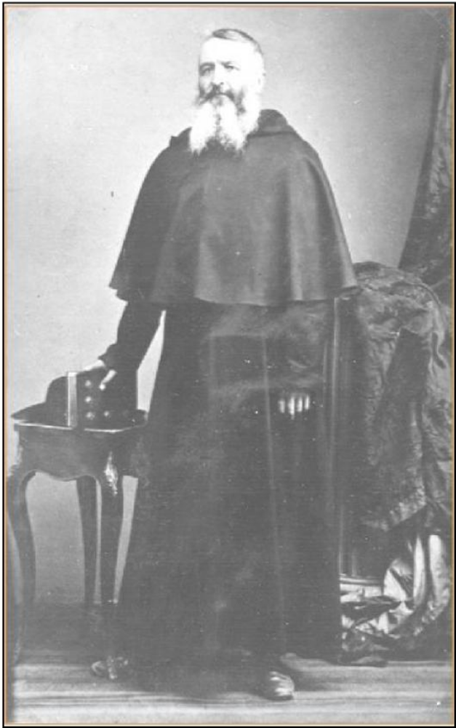
Fr. d’Alzon after his return from the Near East, in 1862
Aware that in the Eastern Church, clergymen had beards, Fr. d’Alzon did not hesitate to allow his own to grow. He kept the beard after returning from Constantinople. “My beard forces me to go see you. This dear beard has become magnificent.” (Lettres, vol. 5, page 29, to Fr. Galabert, 16 March 1864, a proof that Fr. d’Alzon still had the beard in 1864, in view of a second trip to the Near East.)

Fifth Turning Point
MISSION IN THE NEAR EAST
3 June 1862
The event
- 3 June 1862, the blessing of Pope Pius IX

“I bless your works in the East and in the West.” The blessing of Pope Pius IX has often been portrayed as entirely unexpected and prophetic. In fact, Father d’Alzon had already heard about Constantinople and Russia from the Resurrectionist Fathers as early as 1846, and for at least a year on his own had thought about bringing his Congregation to Jerusalem. It remains true, however, that the Assumption will always consider the blessing of Pope Pius IX, on the 3rd of June in 1862, as a turning point in Father d’Alzon’s life and for the entire Congregation. Father d’Alzon’s apostolic zeal and his spirit of initiative are well known. He had already been committed to a wide variety of projects by the time he became involved, at the request of Pope Pius IX, in a new and unexpected apostolic endeavor, which deeply affected the missionary character of the Assumption, founded seventeen years earlier, and brought him to found a new Congregation, the Oblates of the Assumption, missionary sisters.

Remote preparation
While on a visit in Paris in 1843, Father d’Alzon met the Resurrectionist religious through the intermediary of Mère Marie Eugénie de Jésus, who was already in communication with them. He admired their desire to resolve the eastern schism. He writes to Marie Eugénie on 2 November 1846 (Lettres, vol. C, p. 149): “This great project opens up a beautiful future to these people whose ambition is to found a community in Constantinople, as well as to dedicate their energies, according to the Pope’s desire, to working in Russia.” Friendly relations and a shared Roman spirit gives birth, in both, to a desire to know each other better and perhaps one day consider a merger.
In the Constitutions of 1855, Father d’Alzon had also foreseen for his Congregation “foreign missions and works to abolish schism and heresy.” A first mission in Australia having ended in failure, we can understand his desire to be sure that it is the Pope’s will before accepting a mission among the uniate Bulgarians.
In 1860, the Christian Maronites of Lebanon (the Ottoman Province of Syria at the time) had suffered oppression at the hands of the Druzes and the Muslims, without the intervention of the Turks. France, the traditional protector of Catholics in the Near East, sent troops to Syria to restore peace. The Bishops of France, responding to an invitation from the Oeuvre des écoles d’Orient, asked the Catholics of France to welcome a number of orphans. Father d’Alzon, participating in this generous offer, accepted to welcome at his own expense eight young people who manifested some attraction to the priesthood. His goal was to form them over a period of ten years to thus constitute the nucleus of a seminary in their own country. This is how the idea was born in him of founding a Maronite seminary in Jerusalem. According to his former student, Pierre Baragnon, stationed in Istanbul, it might even have been possible to purchase the Cenacle for this purpose. The Prefect of the Congregation for the Propagation of the Faith in Rome was informed of these projects; the Patriarch in Jerusalem was entirely supportive, as was Msgr. Lavigerie, Director at that time of the Oeuvre des écoles d’Orient.
We see here an example of Father d’Alzon’s generosity inasmuch as he assumed the cost of six years of lodging for these young Syirans, and of his desire to undertake no project without the explicit authorization of Rome. It is likewise an example of his respect for the Oriental rites. Though he thought that these young men, in his residence, should follow the Latin rite, he was also of the opinion that they should not forget their own and that therefore they should be formed in their own country. His desire to awaken and encourage vocations reminds us of what he will say at the end of his life, that he was happy to have given to God so many consecrated souls.

Description of this turning point
When Fr. d’Alzon went to Rome with the pilgrims from Nîmes, from the 19th of May to the 15th of June 1862, he had already been considering a mission in the Near East and about which he wanted speak with Cardinal Barnabo, Prefect of the Congregation for the Propagation of the Faith. After the death of his sister Augustine and then of his mother in 1860, he was his mother’s sole heir with his sister Marie de Puységur. At the end of 1861, an agreement was reached between himself and his sister regarding the inheritance, and he found himself in possession of a substantial fortune, made up mostly of properties (including the house of the Condamine at Le Vigan and a number of farms) that he would eventually sell. In Rome, it was known that he had 400,000 franks to dispose of to buy Palestinian holy places and to found a Maronite seminary.
On the boat from Marseille to Civitavecchia, Father d’Alzon spoke of these projects with Fr. Jerome Kajziewicz, who was also taking part in the same pilgrimage. It so happens that Fr. Jerome was also the Superior General of the Polish Resurrectionists, with whom the possibility of a merger was still under consideration. Fr. Jerome was hoping to found a mission among the Bulgarian Slavs, but he knew that the Pope did not want to confide this mission to Polish religious in order to avoid conflicts with the Russians.
On Tuesday morning, 17 May, while his Bishop, Msgr. Plantier was being received by the Pope, Fr. d’Alzon met a number of Prelates, who discouraged him from his project to buy the Cenacle and to establish a Maronite seminary in Jerusalem. Informed and influenced by Fr. Jerome, who hoped to establish himself in Istanbul thanks to Fr. d’Alzon, they told Fr. d’Alzon that the Pope preferred to see him turn instead to the Balkans. In a note of June 1862 (Ecrits spirituals, p. 1449-1451), Fr. d’Alzon says the following: “When I arrived in Rome, Msgr. Howard pushed me in the direction of the Bulgarians, as did Msgr. Lavigerie and Msgr. Talbot. I responded by saying that I had begun a project among the Syrians, with the agreement of Cardinal Barnabo, a project that I could not alter without a clear direction from the Holy Father or from the Congregation for the Propagation of the Faith. Otherwise, I would not be taken seriously.”
On Tuesday, 3 June 1862, during the public audience granted to the pilgrims from Nîmes, Pius IX, speaking directly to Fr. d’Alzon, said: “I bless your works in the East and in the West.” The words are still well known in the Assumption, considered to be prophetic since the Assumption had no works “in the east”. But for Fr. d’Alzon, this expression did not clearly enough express the Pope’s will, and it was not entirely surprising to him since if he did not have any specific works in the Orient he did have some plans for Jerusalem. In the evening on Tuesday, the third of June, Msgr. Simeoni, Cardinal Barnabo’s secretary, communicated the Cardinal’s hesitations to the Pope, but the Pope repeated: “And if I say this is what I want...” Fr. d’Alzon was told that the Pope wanted to see him and that he should present himself for an audience on the following Friday morning.
On Friday, 6 June, during the private audience given by Pius IX to Fr. d’Alzon, the Pope made clear his intention. We read once again Fr. d’Alzon’s note: “On Friday, 6 June, I went to the Vatican at 9:15 and waited for only five minutes. The Pope received me in his private library. He spoke first, saying that he was well informed of the dossier and approved of everything. The idea of a college to prepare the Bulgarians for their return to the Catholic faith seemed to be a necessity, as far as he was concerned. The difficulty was in renewing the country through its priests given the fact that the priests were more corrupt than the people. I spoke to him of the Polish priests who could help us. He approved of the idea on condition that the Propagation would give its agreement to the choices I would make. He told me that the Polish were good people but sometimes imprudent... After leaving the Pope’s library, I went to see Simeoni, who was in the midst of a discussion with Barnabo. He was very happy with the turn of events and encouraged me to follow the directions given by Pius IX. I asked him to request an audience for me with Barnabo, who granted it for that very evening. I was clear. I excused myself before him, and he was most correct. [Barnabo had approved the Jerusalem project and was reticent regarding the Balkans.] I should say that he deeply edified me by the vigor with which he said that it was important always to follow the Pope’s direction since he had the permanent assistance of the Holy Spirit, whereas he did not. He suggested I send two people to Constantinople and to Bulgaria, to study the state of affairs. He offered letters of presentation...” (the note is incomplete)
Was Fr. d’Alzon being taken advantage of? Certainly, and he was very much aware of the fact. He wanted to pursue his plans to found a Maronite seminary in Jerusalem and was forced to abandon them in favor of a mission among the Bulgarians. He insisted that the Pope express his will clearly to avoid giving the impression that he was not consistent in his projects. It is often said that God writes straight with crooked lines and that the “will of God” is often accomplished by very human intrigues.
From the time of his studies in Rome, Fr. d’Alzon had no illusions about the Roman context, but he always considered this in the light of faith. For him, the word of the Pope was the expression of the will of God. He himself will often refer to this blessing of Pius IX to underline the fact that he received this mission to the Bulgarians directly from the Pope himself.

The implementation of the Mission in the Near East
Once the new mission had been confided to him, Fr. d’Alzon gave himself to it wholeheartedly, and he did so until the end of his life. He gave to the project a great deal of time and energy, always seeking to be informed regarding the evolution of the religious and of the geo-political situation, adjusting his plans in the light of circumstances and opportunities. He even dreamt of projects that would not begin until after his death, such as the sending of religious to Russia.
As planned, Fr. Jerome Kajziewicz went to Constantinople already in the summer of 1862, but the Resurrectionists took for themselves the mission among the uniate Bulgarians and suggested that the Assumptionists focus their attention on the Greeks and Romanians.
On 20 December 1862, Fr. d’Alzon sent Fr. Galabert to Constantinople before he himself undertook the same journey, with a stop in Rome on the way.
Invited by Msgr. Brunoni, the Patriarchal Apostolic Vicar of Constantinople, to give the Lenten sermons, he left Marseille on 14 February 1863 for Constantinople. He stayed there from 22 February to 5 April. He was in contact with many people, but became very quickly aware of the rivalries and competing interests. However, he sought to remain faithful to the directives received from Rome and to work in concert with Msgr. Brunoni and Msgr. Hassoun. He foresaw the establishment of the seminary that was requested, if not in Constantinople then at Kadikoÿ, formerly Chalcedon, where he sought to purchase a property, to be given after his departure to the Vicar General of Msgr. Brunoni. He foresaw likewise the presence of religious sisters and naturally thought of Mère Marie Eugénie de Jésus. He explained to her the possibility of having a school, of forming teachers, of promoting the devotion to the Blessed Sacrament. He drafted a long report to be submitted to the Congregation for the Propagation of the Faith, in which he referred to the desires of Msgr. Brunoni, different from those of Rome, which was eager to promote the uniate Churches. To Fr. d’Alzon’s dismay, his report was not well received. This was not a mission he had sought himself, and yet he was ready to do what was asked of him.
Concretely, the mission will be realized, but at Philippopoli (Plovdiv). Fr. Galabert succeeded in winning over the uniate Bulgarians and thanks to Msgr. Canova, the apostolic delegate in Bulgaria, he was able to open a primary school in Philippopoli. In October of 1863, for the sake of good communications with the Congregation for the Propagation of the Faith, Fr. d’Alzon informed Cardinal Barnabo of the sending of his religious in view of founding a school in Philippopoli, while not setting aside the possibility of opening a seminary. He added that he was trying to relieve Msgr. Brunoni of his financial worries. As it turned out, it was impossible to establish a seminary in Constantinople as a result of the ineptitude of Msgr. Brunoni’s Vicar General. Fr. d’Alzon also informed the Holy See regarding the finances of the Bulgarian seminary, even though the implementation of this project was rather in the hands of the Resurrectionists, yet another sign of Fr. d’Alzon’s generosity and disinterestedness.

The foundation of the Oblates of the Assumption
As early as 23 February 1863, Fr. d’Alzon had written to Mère Marie Eugénie from Constantinople of his desire to have religious sisters working with him in the Near East. She responded on 8 March 1863 that in theory she was in agreement, but she wanted to discuss it further with him upon his return. Unfortunately, her Council was reticent, and the proposal was remanded to the Chapter of 1864.
In a letter to her of 1 November 1864, Fr. d’Alzon suggested the establishment of Oblate tertiaries, referring to the categories of sisters mentioned in their statutes, with the name Oblates of the Assumption, alongside the choir sisters and the lay sisters. This idea is abandoned when the foundress on whom they were counting decided instead to be a religious. In his letter to Mère Marie Eugénie of 6 March 1865, Fr. d’Alzon writes: “Pauline will be leaving for Paris. That’s a disappointment for me, added to some others, but they all detach me from this world and push me rather to heaven... I’ve spent a few days at Le Vigan and was surprised to see the great number of vocations for the Oblates and for the lay sisters that we would find if we wanted.” (Lettres, vol. 5, p. 261)
Reacting to this initial setback and in the face of the dedication that he discovers in the Cevennes mountain region where Fr. Hyppolite Saugrain had worked so well, Fr. d’Alzon began thinking of a small distinct Congregation that would find its support in the Religious Sisters of the Assumption in France and the Assumptionists in the Near East “following the example of Saint Vincent de Paul”, as he writes (Lettres, vol. 5, p. 332 to Mère Marie Eugénie). To help him with the formation of these vocations, he asks Mère Marie Eugénie to send one of her best sisters, Mère Marie-Madeleine.
The Oblates of the Assumption consider the 24th of May to be the day when they were founded at Le Vigan, in a rented home in the Rochebelle neighborhood, a house they called Our Lady of Bulgaria.
However, the first Oblates will profess vows only after the profession of the one that Father d’Alzon had chosen as their Mother and whom he was preparing in Nîmes. Marie Correnson will make profession on 18 April 1868, followed on 19 April by that of the first five Oblates to be assigned to the mission in the Near East. Other professions will follow on the 6th and the 19th of September. The Congregation then had sixteen professed members, including the foundress, and a great number of novices.
Having become the founder of a second Congregation, Father d’Alzon will devote a good part of his time to stimulating the apostolic zeal of these sisters who were giving their lives for the foreign missions. His presence in Rome during the first Vatican Council will be an opportunity for him to measure the missionary breadth of the Catholic Church and to open his own missionary vision to the entire Slavic world. He will nourish the dream that will become the obsession of his last ten years: to bring great Russia back into the Roman fold! On 17 November 1869 (from Rome, during the Council) he writes to Mère Correnson: “Besides the Bulgarians there is the enormous population of schismatic Slavs, of which the Bulgarians form only one part. There are at least sixty million people to convert. Nothing more, nothing less! ... Do you know, one of the most moving experiences I am having in Rome right now? It’s to be meeting Bishops from all over the world... And in all of these countries there are immense victories to be won, and most of them are mission countries where the Oblates could work.” (Lettres, vol. 8, p. 15).

An obsession with Russia
In his closing address to the General Chapter of 1873 (Ecrits spirituels, p. 185-186), Father d’Alzon said:
“I have not yet spoken of our foreign missions. If for the time being we must leave Australia aside because certain commitments were not respected, some good work is being done in Bulgaria: an organization for employers and apprentices, a school for two hundred boys... Our Oblate sisters have provided wonderful assistance with the work they do in a hospital, a dispensary, a student residence, in schools. All of this is just beginning, but it is a valuable first-stage in our work against the Greek and Russian schism! We might be accused of temerity: who are we to confront such a giant?
“Today the Church has three enemies: the revolution, Prussia, and Russia, and Russia is far from the least of these. And yet, what great opportunities for our efforts in these areas! As Jesus said to his disciples, so I say to you: “Messis multa.” The disciples, who had become apostles, conquered the world. My brothers, how much do you want to conquer Russia and bring back an abundant harvest to the storehouse of the Father? I am somewhat intimidated as I say all of this to you, and yet something tells me that if this is what the Assumption wants, with God’s help, the harvest will be hers.”

He no longer considered the mission in Bulgaria as anything other than a way of getting into Russia, and he continually pushed Fr. Galabert in this direction. On the 19th of July in 1875 he spoke to him of a house in Odessa:
“Do you know the first foundation I would like to make? A house in Odessa. I know that’s hard, but that’s what I think. There’s something to be done in that sense. We should consider Russia to be our goal, and the difficulties should not stop us.” (Lettres, vol. 11, p. 168).

On the 19th of August 1876 he wrote to Father Galabert:
“Sooner or later, Russia will open its doors to us, even if we have to grease the locks and the hinges with our blood.” . (Lettres, vol. 11, p. 372).
Father d’Alzon asked for a sign from heaven to confirm his mission in Russia: the sign of the healing of an Oblate. On 3 September 1877 he wrote to Fr. Picard :
“I admit that if I stayed at Lourdes for twenty-four hours after the pilgrimage that you directed, it is because I wanted to ask the Blessed Virgin for a sign that she approved our efforts to work for the conversion of the eastern schismatics. Would not the healing of my Oblate, who is consecrated especially to this mission, be the sign granted?” (Lettres, vol. 12, p. 174).

In a note of 30 March 1878 to the Congregation for the Propagation of the Faith (Ecrits spirituels, p. 1455-1459), Father d’Alzon recalled the event of 1862 and what he had done since in the Near East, then presented his Russian projects:
“I would like to raise another series of questions. Ever since Pius IX suggested the mission in Bulgaria, my sights have extended even further: Russia has become my great preoccupation. Around the month of May 1877, less than a year ago, having been received by the Holy Father, I took the liberty of asking for his blessing and his encouragement in view of preparing a seminary to form missionaries for Russia. Pius IX encouraged me a great deal, gave me his blessing, and I left him, taken up with this thought. Since then, a Catholic Russian woman has offered to provide space on her property in the Caucasus, with a few young people...”
[This Russian woman, converted to Catholicism, is Mrs. Fricero, natural daughter of the Tzar; cf. AA Info, #5, September 2006.] Father d’Alzon questioned her on the political and religious situation of Russia, on the possibility of going there, etc. He sent her his notes on the evangelization of Russia, and basing himself on certain passages of her letters, sketched a plan for a foundation in the Caucasus. Father d’Alzon’s letters to Mrs. Fricero are not known to us, but we have the last ones she wrote to Fr. d’Alzon between the 15th of August 1877 and the 30th of January 1879.
Until the end, Fr. d’Alzon remained interested in developments in Russia. In the very year that he died, he wrote a three-part article on the subject in the three first numbers of the periodical, La Croix.

Conclusion
The event of 3 June 1862 is an example of Fr. d’Alzon’s love for the Church and his perfect submission to the will of his superiors. Already, this love for the Church led him as a young priest at the service of his diocese to desire to work for the conversion of Protestants. His Bishops urged him to exercise moderation, but the desire to work for the unity of the Church always remained close to his heart and found new expression when the mission in Bulgaria was entrusted to him. With the breadth of vision characteristic of him, he very quickly seeks to open this mission up to include Russia.
The apostolic zeal of the Assumption seeks to be “daring, generous, disinterested.” Father d’Alzon was the first one to display such qualities:
- He dared to send the most competent religious for this new mission, at a time when he had only a handful. (Fr. Galabert was a medical doctor and a doctor in canon law.)
- It is important to note the generosity on his part, a generosity that was clear already at the beginning of this entire adventure; he will dedicated to the mission a good part of the fortune that he had just inherited.
- As for his disinterestedness, it was clear not only at the level of finances, but also in terms of his willingness to surrender parts of his apostolic projects to others.

Biblical texts that help us understand this turning point
- John 10:1-16 (the desire of Christ to see his disciples constitute one flock under one pastor)
- John 17:21 (Jesus‟ prayer for unity)
- Genesis 13 (Abraham’s separation from Lot, who keeps the fertile plain for himself)

Brief bibliography
- E. D’ALZON, Ecrits Spirituels, Rome, 1956, p. 1448 to 1460.
- Siméon VAILHÉ, Vie du P. Emmanuel d’Alzon, vol. II, ch. XIV (Jerusalem or Bulgaria?), XV (Istanbul and the Near East question), XVI (The Foundation of the Oblates of the Assumption), and XXV (The Near East Mission), Paris, 1934.
- Pierre TOUVENERAUD, « Religieux et religieuses de l‟Assomption au service de l‟Orient chrétien », p. 431-436, in Pages d’Archives, II, March, 1965, p. 419-452.
- Julian WALTER, The Assumptionists in the Near East (1863- 1980), Centennial Series, 1980, #6, Paris, 1982.
- Daniel OLIVIER, Le Pere d’Alzon et l’œcuménisme, Centennial Series, 1980, #7, Paris, 1982.
- Etienne FOUILLOUX, « L‟œuvre orientale du Père d’Alzon vue par ses fils, » in Emmanuel d’Alzon dans la société et dans l’Eglise du XIXe siècle, Colloquium under the direction of René RÉMOND and Emile POULAT (December, 1980), Paris, Editions du Centurion, 1982, p. 199-220.
- La Mission d’Orient, L’autre poumon de l’Assomption. Editions du Signe, 2007.
- La Mission d’Orient de l’Assomption. Cahiers du Bicentenaire d’Alzon, #6, Rome 2008. This volume includes an extensive bibliography (pp. 165-177 and 179-208).
Jean-Daniel Gullung, a.a.

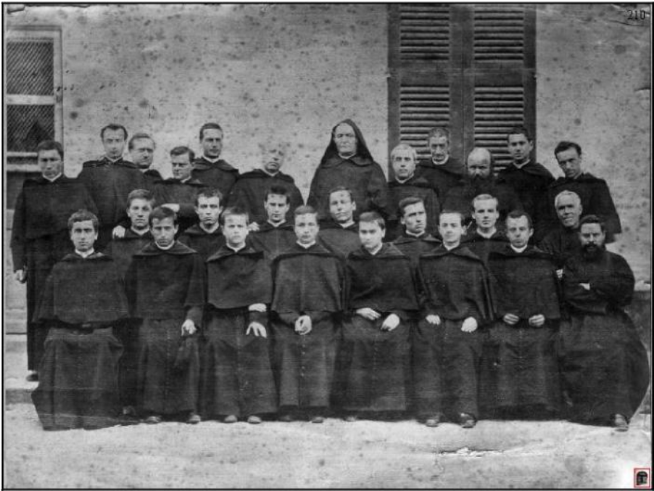
Fr. d’Alzon, photographed with a group of his religious 29 September 1879
Photograph taken at Nîmes with the religious who had gathered for the annual retreat; it is the last photograph of him in a group.

Sixth Turning Point
EMMANUEL D’ALZON “PASSES THE TORCH”
The event
- The General Chapters of 1868, 1873 and 1876
Significant dates :
- 17 September 1868: Closing Address to the Chapter
- 18 September 1873: Closing Address to the Chapter
- 11-18 September 1876: Creation of Provinces by the General Chapter

Description of the turning point
Emmanuel d’Alzon’s final years were a time of attentive listening, of renunciation, of kenosis, of surrender. Already at the end of the 60s, his major concern was to assure the growth and accompaniment of his disciples in order to prepare them to take over from him. To that end, he made an effort to articulate the essential elements of his thought regarding the spirit of the Assumption and to define in that way the Congregation’s common objectives.
This was the specific goal of his closing address to the General Chapter of 1868. In this speech, Fr. d’Alzon summed up the spirit of the Assumption in the “triple love” of “Our Lord Jesus Christ”, “the Blessed Virgin, his Mother” and “the Church, his spouse.” In this way he fleshed out the central theme of the Directory (approved by the Chapter of 1868), and he related in a more coherent manner the coming of the Kingdom (Adveniat Regnum Tuum) with the love of Christ and what Christ loved the most (...propter amorem Domini nostri Iesu Christi).
In the months preceding the Chapter and in the years following, the founder insisted even more on the interior life and invested himself more in the spiritual formation of his disciples (cf. Vailhé, vol. 2, p. 675).
He passed the torch to his “sons”. He made clear to them his confidence and his affection and accompanied them in their apostolic projects. Even if Father d’Alzon felt it necessary to take charge once again of the novitiate in Nîmes, the division of the Congregation into three Provinces, something that he desired and that was adopted by the General Chapter of 1876, constituted yet another important step in the process of transmitting authority. Father d’Alzon also followed closely the development of the Oblate sisters. After the profession of some of the first sisters, after their departure for the Near East and after the installation of Marie Correnson at the head of the young Congregation, he drafted for them what he himself called his “spiritual testament”.
This was a period when, feeling certain physical limitations, the founder sought to develop the interior dimension of his project. It was also a time of openness and of fruitfulness, as manifested especially in the apostolic work of his disciples. The emphasis was more on the popular dimension of the apostolate (press, alumnates, social works, pilgrimages, etc.). The address to the General Chapter of 1873 developed these topics in a particular way.
You could say that Father d’Alzon, becoming more aware that the end of his life was approaching, wanted to assure the stability of his foundation, to formulate the essential elements of his “spiritual heritage” and to prepare his religious to assume responsibility for its development. This passing of the torch was also a kind of spiritual and apostolic testament. In his address to the General Chapter of 1868, he spoke explicitly of such a testament: “As we come to the end of our work, I would like to confide to you, if I may speak this way, the testament of our common thinking and our common feelings, by reminding you once again, perhaps for the last time, of the foundation on which the work of the Assumption rests and by what means we want more than ever to see this foundation develop.” (Ecrits spirituels, p. 130)
This period is thus a decisive spiritual process, a transferral of responsibility. Father d’Alzon initiated a kind of “Passover”, a gift of life to be received by his disciples. In the light of what has been said, we could think that when he spoke his last words “Be good religious!” (Ecrits spirituels, p. 1463), Father d’Alzon had in his heart and in his mind the entire spiritual “heritage” that he had transmitted to his disciples during this period and, in particular, this “spirit of the Assumption” that he hoped they would now assume as their own and develop even further.

Other important events of this period
Father d’Alzon was taken up by a number of other important events during this same period. They clearly had an impact on his theological reading of history (see the events that followed upon the taking of Rome, in 410, and which inspired Augustine’s City of God):
- Vatican Council I (1869-1870)
- The French defeat of 1870 and the Commune of Paris (1871)
- The taking of Rome and the loss of the Pontifical States (1871)
- D’Alzon’s battle for the freedom of instruction (1870-1871)

Texts of Emmanuel d’Alzon that help us understand this turning point
- Closing address to the General Chapter of 1868 (Ecrits spirituels, p. 129)
- Closing address to the General Chapter of 1873 (Ecrits spirituels, p. 173)
- Letters to the Master of Novices of 1868-1869 (Ecrits spirituels, p. 147)
- Many letters, especially to religious to whom he had entrusted important responsibilities: Fr. Picard in Paris, Fr. Galabert in the Near East, etc.

Biblical texts that help us understand this turning point
- John 15:8-16 (“I no longer call you servants, but friends.”)
- 2 Timothy 4:6-7 (“I have come to the end of my journey...”)
- 1 Timothy 6:11-16 (recommendations of the Apostle)
- 2 Timothy 2:1-3 (“Take your share of suffering for the proclamation of the Gospel...”)
- 2 Kings 2:11-14 (the mantle of Elijah)

Brief bibliography
- Jean-Paul PÉRIER-MUZET, Le Pere Emmanuel d’Alzon par lui-même. Anthologie Alzonienne, vol. II, Rome, 2007, p. 207-210.
- Une dernière décennie de combats, in « Emmanuel d’Alzon fondateur », Collection Vienne Ton Règne, Paris, 2007, p. 29-31.
- Jean-Paul PÉRIER-MUZET, Prier 15 jours avec Emmanuel d’Alzon, Paris, 2003, p. 99-112.
- Athanase SAGE, Un maître spirituel du XIXe siècle, les étapes de la pensée du P. d’Alzon, Rome 1956.
- Siméon VAILHÉ, Vie du Pere Emmanuel d’Alzon, vol. II, Paris, 1934, p. 674-697.

Excerpts
I. INSTRUCTIONS to the GENERAL CHAPTERS of 1868 and 1873
Closing Instruction to the General Chapter of 1868 (Ecrits spirituels, p. 129)
In this address, Father d’Alzon articulated the core of his thinking on the Assumptionist spirit and in that context defined the common project of the Congregation.
(...) As we take leave of one another, I want to entrust to you, if I may put it this way, the legacy of our common thinking and of our common sentiments, by reminding you once again, and probably for the last time, on what foundation the Assumption is built, and by what means we want to develop it further...
Our spiritual life, our religious substance, our raison d’etre as Augustinians of the Assumption, is to be found in our motto, Thy Kingdom Come. The coming of the reign of God in our souls, by the practice of the Christian virtues and of the evangelical counsels in keeping with our vocation; the coming of the reign of God in the world by the struggle against Satan and the conquest of the souls ransomed by Our Lord and yet still buried in the depths of error and sin. What could be more simple! What could be more ordinary than this form of the love of God! If to this basic love you add the love of Our Lord Jesus Christ, the love of the Blessed Virgin His Mother, and of the Church His Spouse, you will know in its most concise form the spirit of the Assumption.
But what is special, what is characteristic in this? (...) We are quite simply Catholic, but as Catholic as it is possible to be. We are Catholics all of one piece...

Closing Instruction to the General Chapter of 1873 (Ecrits spirituels, p. 174)
In this address, Father d’Alzon set forth a plan of action for future apostolic projects and for the organization of the Congregation.
(...) What vast horizons open up before us! Let me try to provide some glimpses, some initial plans. We will have summarized everything when we have said that our goal is the restoration of Catholic mores by faith in Christian principles.

What follows is a listing of possible activities: pilgrimages, eucharistic devotions, orphanages, agricultural schools, social works...
But the action I am proposing to you is based upon certain ideas: the principles of faith... Such ideas must be disseminated and made accessible to everyone. To accomplish this, suitable means must be employed.

Father d'Alzon pursued his talk by giving recommendations for the recruitment and formation of religious, in particular by means of alumnates, and he concludes with a triple reminder and a triple exhortation.
(...) As for what concerns us, let us seek to attract, and avoid distrust which belittles. May confidence be one of our major means of bringing about the victory of the cause of truth. We do not own the truth; we are only its servants... The great evil of our times is darkness, lying. Let us remain in the truth. Let us serve the truth, witness to it, spread it. Then we will have done our job and will not have succumbed to illusion... Some say they are prudent because they dare take no risks; but now more than ever is the time to repeat Bossuet’s saying: “Faith is daring.” Let us have the boldness of faith, even though some might call it foolhardiness.

II. LETTERS
On the future of the Congregation and the organization of its works

Letter to Fr. Picard, 30 March 1867, from Nîmes (Lettres, vol. 6, p. 231)
(...) My thinking often focuses on the future of our little Society, and I must admit that I wonder why there have been so many contradictions at the beginning. Alas, I’m well aware that contradictions are the prerogatives of the works of God, but we need to distinguish between fruitful contradictions and sterile contradictions. And what frightens me is the profound sterility of ours. Do all you can, dear friend, to pray to God to enlighten us on this very important question...
Letter to Mère Marie-Eugénie, 19 December 1868, from Nîmes (Lettres, vol. 7, p. 197)
(...) The more I go, the more I want the Assumption to progress before I die. (...)
See also the letters to Fr. Galabert (11 March 1867, Lettres, vol. 6, p. 226); to Mère Marie-Eugénie (12 August 1867, Lettres, vol. 6, p. 316); to Fr. Galabert (9 August 1868, Lettres, vol. 7, p. 121); to Fr. Picard (14 August 1868, Lettres, vol. 7, p. 126); to Fr. Picard (18 August 1868, Lettres, vol. 7, p. 137);

On his spiritual experience
Letter to Mère Marie-Eugénie, 5 April 1868, from Nîmes (Lettres, vol. 7, p. 58)
I am praying for your retreat; pray also for me. The good Lord is working on me, and if you come at the end of April, I will speak to you more about myself than you have heard for a long time. I’m wondering if I shouldn‟t withdraw to a life of prayer, which the distraction of visits is stopping me from practicing and to which I nonetheless feel myself drawn.
See also the letters to Father Picard (5 April 1867, Lettres, vol. 6, p. 234, and 1 June 1868, Lettres, vol. 7, p. 83).

On the accompanying of his “sons”
Letter to the brothers at Philippopoli, 30 December 1868, from Nîmes (Lettres, vol. 7, p. 201)
Dear beloved brothers,
(...) May Our Lord fill you with gifts and inspire in you a great desire to live always a regular life, in charity, obedience and poverty! Believe that you‟ll never do much good unless you are living as good religious. Our Lord needs good workers. Be apostolic men... Finally, what’s essential is to become saints.
See also letters to Father Vincent de Paul Bailly (24 August 1867, Lettres, vol. 6 p. 337, and 31 August 1867, Lettres, vol. 6, p. 349) and to Father Picard (24 June 1868, Lettres, vol. 7, p. 97).

Expressions of friendship and affection
Letter to Fr. Galabert, 10 January 1868, from Nîmes (Lettres, vol. 1 p. 62)
Good-bye, dear friend. We love you tremendously and pray that you become a saint.
Letter to Fr. V. de P. Bailly, 22 April 1868, from Nîmes (Lettres, vol. 7, p. 62)
...What more can I say? That I love you well. That’s already known; but since it’s good to hear it said, I’m not bothered to have you hear it. I suspect that this provides a bit of velvet for the heart. Adieu, very dear friend. A thousand times to you in Our Lord.
See also the letters to Father François Picard (14 August 1868, Lettres, vol. 7, p. 136) and to Father Hippolyte Saugrain (21 August 1868, Lettres, vol. 7, p. 144) and many others.

On the accompaniment of the Oblates and of Marie Correnson
Letter to Mère M.-E. Correnson, 20 June 1868, from Nîmes (Lettres, t. VII, p. 90).
Don’t kill yourself, but in making every effort to become a true saint, remember that God blesses you with many graces, and what’s true for mothers in a family is true for mothers of communities: they are condemned to give birth in pain.
A thousand good wishes to our daughters. Believe me, my dear little Mother, that everything you are doing is written in letters of gold in heaven if you do it perfectly.
See also the letter of 10 September 1876 to the Oblates of the Assumption (Lettres, vol. 11, p. 465).
André Brombart, a.a.

The General Council decided that the works in this collection, once they are translated into French and Spanish, could be published in digital form (on CD), a more practical and economical mode of publication.
During his entire life, d‟Alzon will continue to reflect on the best way to renew society. To show how this thinking evolved, read the articles he wrote for the journal, Liberté pour tous (in 1848) and his speeches to the General Chapters of 1868 and 1873.
“This simple gesture put into practice in the most praiseworthy manner the love for the Pope that Father d‟Alzon places at the beginning of his Rule. On more than one occasion, his sons will follow his example, which inspires in them the same courage and faith.” (Polyeucte GUISSARD, p. 49).
See letter of 11 December 1853 (Lettres, vol. 1, p. 354). Until May of 1853, no week passed without some reference in his writings to his suffering. For example, read the letters of 7, 9, 20, and 21 June 1853 to Marie Eugénie (Lettres, vol. 1, p. 291); 21 June 1853 to Amélie de Pelissier (“I have absolutely no physical strength and the smallest amount of work tires me tremendously.”); 24 June 1853 to Adolphe Amouroux (Lettres, vol. 1, p. 302); 4 July 1853 to Amélie de Pelissier (Lettres, vol. 1, p. 291 ff).
He wrote on 26 September 1848: “I can even experience a certain peace in the thought that God will ask of me the disappearance of the Assumption and all of the humiliation and suffering that will ensue for me. I am determined to do everything I can to impede this, in accordance with God‟s will, but always with this thought: In all things, we should want only what God wants and love only what He loves and to the extent that He loves it, and for the same reasons.” (Adrien PÉPIN, p. 159).
Letter to Mr. Germer-Durand, 1 July 1857 (Lettres, vol. 2, p. 273).
Read Jean-Paul PÉRIER-MUZET, Le Père Emmanuel d’Alzon par lui-même, Anthologie alzonienne, t. I, Rome 2003, p. 119. See also Adrien PÉPIN, op. cit., p. 237.
For him study was extremely important, as was giving retreats and preaching, and now intellectual activity was almost entirely impossible. He found himself in a state that he called “intellectual collapse.” If he was not at his desk preparing a sermon, he was on the road in various churches for the Kingdom of God. And now he was nailed to his bed! From an aristocratic background and a rich family, here he was a beggar, spending his days on the roadside to see if a good Samaritan would lend a helping hand. Many people in such a situation could not avoid becoming depressed or even being tempted by suicide. This was not the case for d‟Alzon, even though he clearly experienced deep discouragement.
Letter of 14 September 1854 to Mère Marie Eugénie (Lettres, vol. 1, p. 459).
Adrien PÉPIN,, op.cit., 240.
Philippians 1:21.
Letter of 29 May 1857 to François Picard, shortly after his ordination (Lettres, vol. 2, p. 87); see also the letter to Mère Marie Eugénie on 19 December 1859 (Lettres, vol. 3, p. 184).
Ecrits spirituels, p. 1229-1231.
Adrien PÉPIN,, op.cit., p. 240.
Letter of 3 June 1855 in Ecrits spirituels, p. 819.
The Congregation was founded by young Polish refugees in Paris. Under the direction of Pierre Semenenko, they established themselves in Rome in 1842 in order to do theological studies and were given by the French government the use of the church of Saint Claude of the Burgundians, which became the center of their Congregation and where a number of Assumptionist students later resided. Today the Church is under the direction of the Blessed Sacrament Fathers.
Father d‟Alzon also hoped to involve the Religious of the Assumption in a foundation in Jerusalem. When Mère Marie Eugénie consulted him regarding a foundation in Beirut, he responded on 17 September 1861: “Do not speak to me too much about Syria. I think that at this time it might be possible to repurchase the tomb of the Blessed Virgin. The Cenacle and the tomb of the Blessed Virgin have been, for a while, my main preoccupations.” (Lettres, vol. 3, pages 510-511). D‟Alzon is not here referring to the tomb of the Virgin in the Kedron valley, but of sites near the Cenacle, eventually acquired by German Benedictines, who later build the church of the Dormation of Mary on Mount Sion.
He continued to work on the Syrian project in Nîmes until 1866, when it became evident, in the opinion of the Committee of the Ecoles d‟Orient, that the emigration of Syrian children to France constituted a “vast exploitation”, and the possibility of priestly vocations nothing other than a pretext for acquiring at low cost a European education.
In his Vie du P. Emmanuel d’Alzon, vol. 2, p. 335, Siméon Vailhé dates this public audience to Thursday, 5 June.

